FISHBONE DIAGRAM
Kauro Ishikawa. 1982. Guide to Quality Control: 18-29

Yonatan Reshef
Faculty of Business
University of Alberta
Edmonton, Alberta
T6G 2R6 CANADA

Cause-and-effect diagrams were developed by Kauro Ishikawa of Tokyo University in 1943 and thus are often called Ishikawa Diagrams. They are also known as fishbone diagrams because of their appearance (in the plotted form). Cause-and-effect diagrams are used to systematically list the different causes that can be attributed to a problem (or an effect). A cause-and-effect diagram can aid in identifying the reasons why a process goes out of control.

There are three main applications of cause-and-effect diagrams:

1. Cause enumeration is one of the most widely used graphical techniques for quality control and improvement. It usually develops through a brainstorming session in which all possible types of causes (however remote they may be) are listed to show their influence on the problem (or effect) in question. Cause enumeration facilitates the identification of root causes because all conceivable causes are listed.

2. In Dispersion analysis, each major cause is thoroughly analyzed by investigating the subcauses and their impact on the quality characteristics (or effect) in question. The cause-and-effect diagram helps us analyze the the reasons for any variability, or dispersion. Unlike cause enumeration where smaller causes that are considered insignificant are still listed, in dispersion analysis, causes that don't fit the selected categories are not listed. Hence, it is possible that the root causes will not be identified in dispersion analysis.

3. When cause-and-effect diagrams are constructed for process analysis, the emphasis is on listing the causes in the sequence in which the operations are actually conducted. The advantage of this diagram is that, since it follows the sequence of the production process, it is easy to assemble and understand. The disadvantage is that similar causes appear again and again, and causes due to a combination of more than one factor are difficult to illustrate.
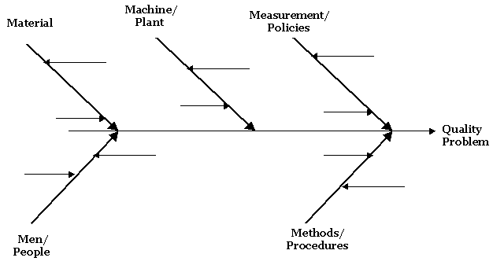
<Picture: Fishbone diagram>

CREATING A FISHBONE DIAGRAM
Cause Enumeration Type

- Identify a quality problem

- Generate causes
Unstructured brainstorming
Structured brainstorming (Round Robin; 6-3-5; etc.)

- Construct the fishbone Diagram

- Use check sheets and Pareto charts to identify root causes (e.g. material, machine, measurement, methods, men) and secondary causes

Ishikawa Diagram

Definition: A graphic tool used to explore and display opinion about sources of variation in a process. (Also called a Cause-and-Effect or Fishbone Diagram.)

Purpose: To arrive at a few key sources that contribute most significantly to the problem being examined. These sources are then targeted for improvement. The diagram also illustrates the relationships among the wide variety of possible contributors to the effect.

The figure below shows a simple Ishikawa diagram. Note that this tool is referred to by several different names: Ishikawa diagram, Cause-and-Effect diagram, Fishbone diagram, and Root Cause Analysis. The first name is after the inventor of the tool, Kaoru Ishikawa (1969) who first used the technique in the 1960s.
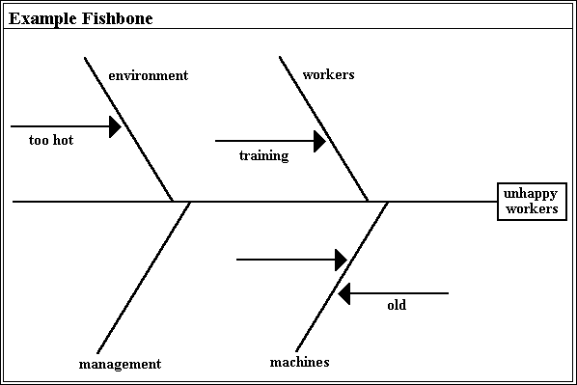
<Picture: Ishikawa Diagram>

The basic concept in the Cause-and-Effect diagram is that the name of a basic problem of interest is entered at the right of the diagram at the end of the main "bone". The main possible causes of the problem (the effect) are drawn as bones off of the main backbone. The "Four-M" categories are typically used as a starting point: "Materials", "Machines", "Manpower", and "Methods". Different names can be chosen to suit the problem at hand, or these general categories can be revised. The key is to have three to six main categories that encompass all possible influences. Brainstorming is typically done to add possible causes to the main "bones" and more specific causes to the "bones" on the main "bones". This subdivision into ever increasing specificity continues as long as the problem areas can be further subdivided. The practical maximum depth of this tree is usually about four or five levels. When the fishbone is complete, one has a rather complete picture of all the possibilities about what could be the root cause for the designated problem.

The Cause-and-Effect diagram can be used by individuals or teams; probably most effectively by a group. A typical utilization is the drawing of a diagram on a blackboard by a team leader who first presents the main problem and asks for assistance from the group to determine the main causes which are subsequently drawn on the board as the main bones of the diagram. The team assists by making suggestions and, eventually, the entire cause and effect diagram is filled out. Once the entire fishbone is complete, team discussion takes place to decide what are the most likely root causes of the problem. These causes are circled to indicate items that should be acted upon, and the use of the tool is complete.

The Ishikawa diagram, like most quality tools, is a visualization and knowledge organization tool. Simply collecting the ideas of a group in a systematic way facilitates the understanding and ultimate diagnosis of the problem. Several computer tools have been created for assisting in creating Ishikawa diagrams. A tool created by the Japanese Union of Scientists and Engineers (JUSE) provides a rather rigid tool with a limited number of bones. Other similar tools can be created using various commercial tools.

Only one tool has been created that adds computer analysis to the fishbone. Bourne et al. (1991) reported using Dempster-Shafer theory (Shafer and Logan, 1987) to systematically organize the beliefs about the various causes that contribute to the main problem. Based on the idea that the main problem has a total belief of one, each remaining bone has a belief assigned to it based on several factors; these include the history of problems of a given bone, events and their causal relationship to the bone, and the belief of the user of the tool about the likelihood that any particular bone is the cause of the problem.

How to Construct:

1.Place the main problem under investigation in a box on the right. 2.Have the team generate and clarify all the potential sources of variation. 3.Use an affinity diagram to sort the process variables into naturally related groups. The labels of these groups are the names for the major bones on the Ishikawa diagram. 4.Place the process variables on the appropriate bones of the Ishikawa diagram. 5.Combine each bone in turn, insuring that the process variables are specific, measurable, and controllable. If they are not, branch or "explode" the process variables until the ends of the branches are specific, measurable, and controllable.

Tip:

•Take care to identify causes rather than symptoms. •Post diagrams to stimulate thinking and get input from other staff. •Self-adhesive notes can be used to construct Ishikawa diagrams. Sources of variation can be rearranged to reflect appropriate categories with minimal rework. •Insure that the ideas placed on the Ishikawa diagram are process variables, not special caused, other problems, tampering, etc. •Review the quick fixes and rephrase them, if possible, so that they are process variables.

References:
•Bourne, et. al. (1991) •Shafer, and Logan. (1987)

Pareto Charts in InfinityQS SPC

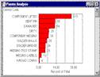
Pareto Chart The typical Pareto Chart provides an indication of the significant codes. The developer of this chart, Italian economist and sociologist, Vilfredo Pareto [1884-1923], called it a way of separating the "vital few" from the "trivial many". A Pareto Chart is a frequency chart typically used to illustrate occurrences of problems or defects. Pareto Analysis organizes the grouped information from the most frequent to the least frequent occurring characteristic and displays them on a bar chart.

InfinityQS SPC enhances the traditional Pareto chart by allowing data to be broken down even further by Minor categories. This feature helps better isolate the cause of a significant problem.

Questions for Making a Decision

Crossroads Considerations
by Alan Harris

1.What is my primary motive as I make this decision?

2.Will my decision cause benefits beyond myself and promote a wider good?

3.Will my course of action unnecessarily diminish or hurt any person or group?

4.Will the consequences of my decision be long-term or temporary?

5.Will I be turning over control of my life to another person or agency?

6.Will I be able to have the necessities of life?

7.What sacrifices will I need to make, and what benefits outweigh these sacrifices?

8.Whose strong influence am I feeling upon my decision, and shall I allow that?

9.What is the worst result my decision can bring, and can I accept that?

10.What safety net will I have if nothing goes as planned?

11.Will high risk be offset by potential growth and deepening?

12.When am I going to stop thinking about this decision and do something?

Collected Poems of Alan Harris presents approximately 200 poems and 400 aphorisms covering a wide range of universal topics, from the whimsical to the inspirational.

Thinker's Daily Ponderable offers a daily original quip which may be intriguing, humorous, or both. Link buttons allow viewing quips for previous days, including archives back to 33 days ago.

Bio of the Author gives some personal history plus outlooks on Web publishing.

E-mail: alhinil@aol.com (Alan Harris)

